# Java CSV : Report

By: Ryan Minneo

***All Results and Data are in this Google Sheet. The first sheet contains the separate tables for plotter, salter, and smoother. The second sheet contains a compressed table and a combined graph.

[Graph: Plotter, Salter, Smoother](https://docs.google.com/spreadsheets/d/1CQPJVeEWWK-xMGqnZUeVdBQ9QsVqhy6550kiXz8iGh8/edit?usp=sharing)

## Plotting: Journal

Naturally, the first part of this assignment was plotting. I knew how to use for loops to generate an (x, y) dataset in terms of an array and ArrayLists for a long time, but placing that data into a csv was a different story.

First, I had to figure out how to even create a file, and then how to create a csvFile. I followed a [youtube video](https://www.youtube.com/watch?v=dHZaqMmQNO4) in order to learn about CSV’s and how to export data into them. This was also my first time using PrintWriter.

I decided to use the class to create an object with an X value and a Y value, and then create an ArrayList of these X’s and Y’s following the parameters and predetermined function, x^2 + 2x + 1.

After the creation of the ArrayList (ends at line 87), then I put a try catch. I realized pretty quickly that working with files can cause a number of exceptions, so I decided to place all the file-related sections into the try catch.

Inside the “try” portion I created a csvFile and a PrintWriter, followed by a for each loop that printed the points into a CSV format.

## Plotting: Results

The plotter actually worked almost exactly as it was supposed to on the first run, the only issue was the interval variable wasn’t working properly.

I tested the program a few different times, tweaking the parameters slightly. Eventually I decided to keep the parameters as (-25, 25, 1) so as to have the graph show a negative portion and a positive portion. I did test that the interval variable does work correctly.

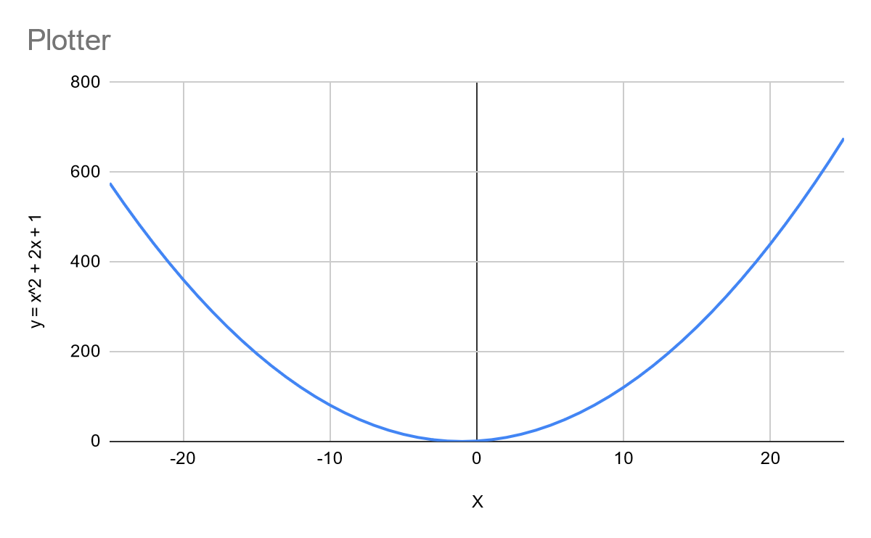

## Salting: Journal

Salting was a little more difficult and it took quite a while to fix all the problems in my code. First I had to learn how to read CSV files. Thus I followed another [video](https://www.youtube.com/watch?v=zKDmzKaAQro) on youtube.

I created a file object referencing the csv that I created in the GraphFunction program. I decided to try to make this code in a compact way. My goal was to read the csv, salt it, and print to another csv in the same loop. The while loop starting at line 38 shows this. I had plenty of problems attempting to modify only the y values in the csv and plenty more problems trying to get the FileReader to find the correct File. Once I corrected the issues, the salter worked as expected, salting the y values of the csv.

## Salting: Results

Through the process of creating the Salter, I learned how to read a csvFile from a java program. The graph for the salted CSV came out perfectly.

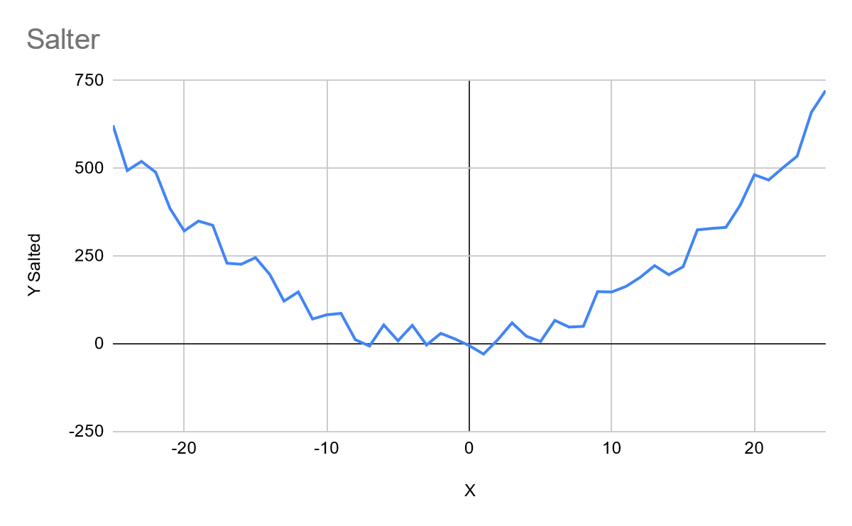

## Smoothing: Journal

This project didn’t really develop a new skill for me; however, it cemented the process of writing and reading csvFiles in java. It was also quite fun trying to average out values based on the windowValue.

I started by copying and pasting my salter, but I ended up deleting most of that code in order to separate the code into different sections. First the BufferedReader will read each line and output the values into an ArrayList of Integers. Then the ArrayList will go through the smoothing process, numTimes. Also wrapping my head around the logic having to do with windowValue was plenty of fun, I assure you. Then the ArrayList gets converted into a csv.

## Smoothing: Results

Overall, the Smoother was pretty fun to make and it developed all of the various csvFile skills in java. Other than the edges of the graph, the smoothed graph is generally very close to the original graph.

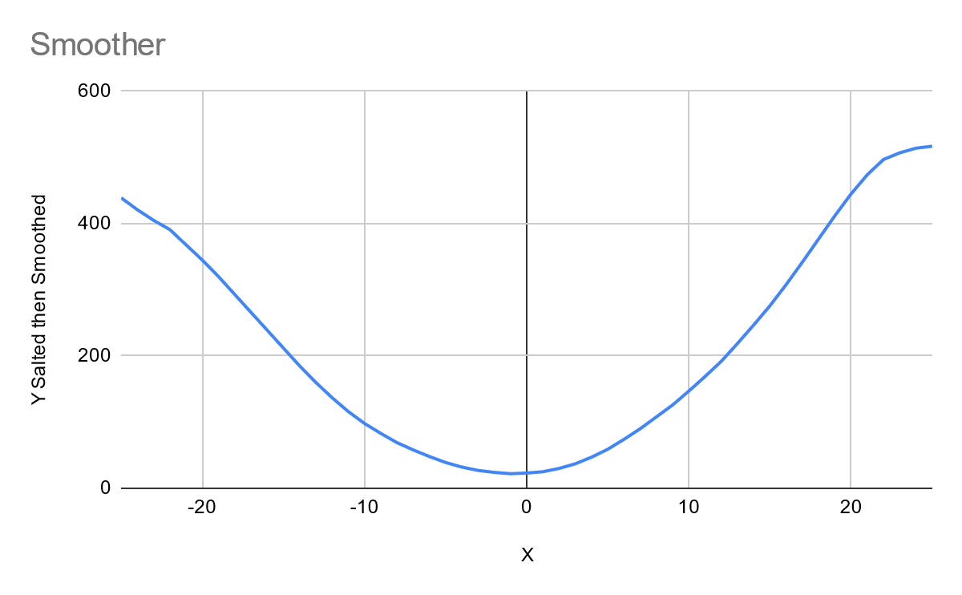

## Overall Results

All of the programs took a good amount of thinking, though I finished the smoother relatively quick thanks to the skills developed during my time creating the plotter and the salter.

Here is a graph showing off the Plotted points, the Salted points, and the Smoothed points:

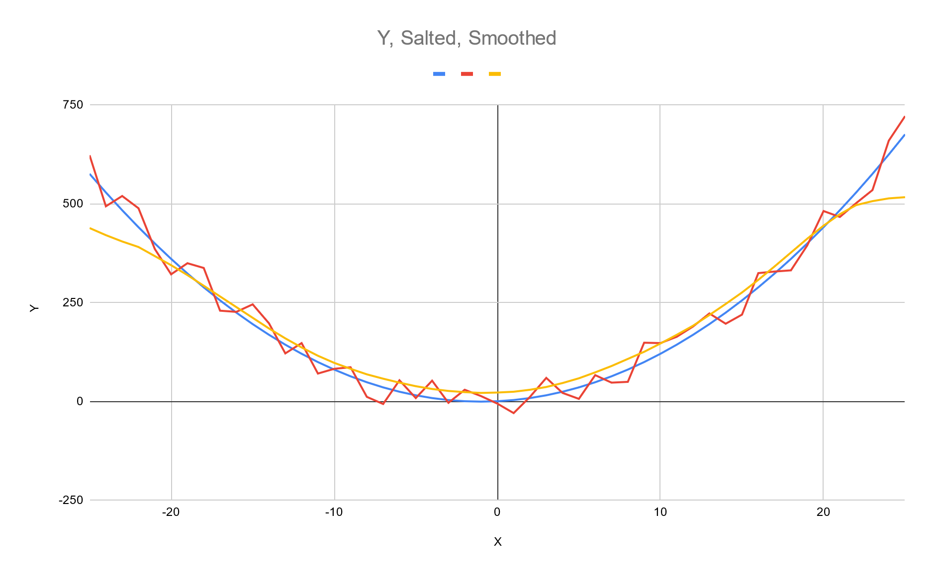

As you can see, the edges start to fall off a little bit, but the yellow/smoothed line generally follows the blue/plotted line.